VEHICLES

There will be four (4) types of vehicles in the game. (1) Main Vehicles , (2) Boss vehicles, (3) Chase/Evade vehicles, (4) Generic Vehicles.

(1) Main Vehicle Specifications

There will be sixteen (12) Main Vehicles - each associated with a particular character (see below):

Speed:
- Bart Ferrini
- Apu Trans Am
- Snake bandit
- Homer Barracuda
- Frink TBD

Control:
- Homer Pink Sedan
- Cletus pickup truck
- Comic Book Guy Gremlin
- Wiggum Police car

Mass:
- Marge Canyonero
- Grampa WWII jeep

Halloween Cars:
- Zombie Speed Buggy

There are a few ways in which the vehicles drive differently:

- Top speed. The top speed will be lower for heavier vehicles. They will be rated on a scale of 1 to 10.
- Collisions with objects in the world/Mass. To compensate for the lower top speed, the heavier vehicles will have a greater physics advantage when colliding with other vehicle. This mass will also have some (subtle) effect on the vehicle’s jumping ability.
- Cornering/Control. Larger, heavier vehicles will corner more poorly than smaller (sports car) vehicles.
- Braking. Heavier vehicles will also take longer to stop.
- Damage. Some vehicles may take more damage than others.

The differences between vehicles will be variables in a vehicle database so that they can be tuned without programming.

(2) Boss Vehicles

The Main Vehicles will also dub as the boss vehicles. Boss vehicles will be AI driven and have direct story or mission reference. They will perform in the same way as the main vehicles and be associated with the same characters.

(3) Evade/Chase Vehicles

There will be 5 different vehicle shapes for all Chase/Evade vehicles. These vehicles should be identifiable from the other vehicles on the road. This can be done by:
- Color
- Shading
- Glow
- Type of vehicle
- Or just through Story and Dialog

There will be no drivers for these vehicles. Therefore, damage should be limited to texture and deformation. There should not be any parts flapping or falling off. When and if these cars are destroyed, there should be a mini ‘poof’ explosion and then a texture change and smoke particles.

(4) Generic Vehicle Models

There will be at least 10 different vehicle shapes that will populate the Simpsons world. To add variety, each vehicle will be available in several different colors. Some will share the same body type will use different textures to add variety. The following is a list of each vehicle type:

 | VEHICLE TYPE |  |  | Available Colors
1 | Truck  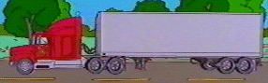 |  |  | Cab - Red, dark blue, light blue, purple, green,  Trailer – Grey with two different shapes (circular and box styles)
 | 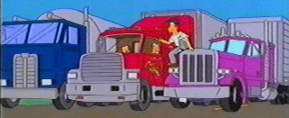
2 | City Bus (Nuclear-powered)  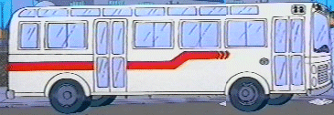 |  |  | White with red stripe. Nuclear green glowing effect emanating from the back of the bus (engine area)
 | 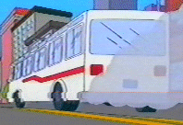
3 | Cube Van  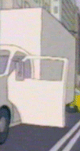 | 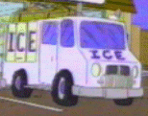  Front of the van |  | Variety of colors such as white cab with white cube, red cab with white box, white box with red cab etc.
4 | Ambulance  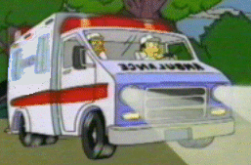  NOTE: Similar to cube van model with the addition of lights on top and a different texture. |  |  | White with red stripe
 | 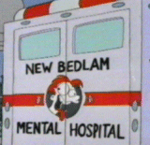 NOTE: Should read “Springfield Back of ambulance Hospital” |  |  | White with red stripe
5 | Police Car  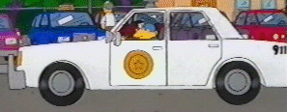  NOTE: Similar to 4 door sedan model with the addition of lights on top and a different texture |  |  | White with blue stripe along side of vehicle (stripe missing from this example)
6 | Minivan  No specific example. Should look like a typical minivan drawn in the Simpsons style. |  |  | Red, orange, pink, baby blue, light blue, purple, green
7 | Station Wagon  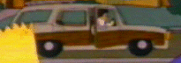  NOTE: Vehicle should just be one color |  |  | Red, orange, pink, baby blue, light blue, purple, green, brown
8 | Sedans  (2 types based on these examples)  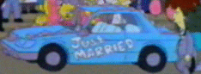 |  | 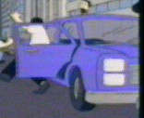 | Red, orange, pink, baby blue, light blue, purple, green
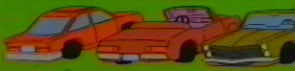

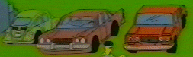

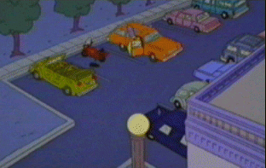

9 | Compact Car  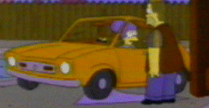 |  |  | Red, orange, pink, baby blue, light blue, purple, green, brown
10 | Sports Car  No specific example. Should be a fairly small 2 seater that looks low and wide with aggressive styling. |  |  | Black, red, blue
 | Various cars  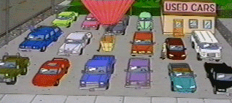 |  |  | Good example of car and color types within the Simpson world…

Vehicle Damage

Main Vehicles
Vehicles will suffer damage upon colliding with another vehicle, a static object (telephone pole, house, etc.), or animated bounding volume. The damage will accumulate as you hit more objects, to the point where the car will be incapacitated. However, the handling of the car will not be compensated (ie. only affect the visual appearance of the car).
- Main vehicles will have multiple stages of damage with a target zone (damage will occur in the quadrant of the impact).
- Generic vehicles will have two stages of damage: undamaged and damaged.
- AI vehicles will be tunable as to how much damage they can take before being incapacitated.

Boss Vehicles
Boss Vehicles will have the same damage states and characteristics as Main vehicles.

Chase/Evade Vehicles
TBA

Generic
TBA

